RPM installs a package file.
YUM downloads and installs packages with dependencies.
DNF is the newer version of YUM.

Package Manager Hierarchy
DNF (Newest)
│
YUM (Older)
│
RPM (Lowest Level)
- RPM → Works directly with .rpm files.
- YUM → Uses RPM internally and automatically downloads dependencies.
- DNF → Replaces YUM in newer CentOS/RHEL versions. Also uses RPM internally.

1. RPM (Red Hat Package Manager)
What is RPM?
RPM is a low-level package manager.
It installs, removes, and checks .rpm package files.
Advantages
- Install local RPM files.
- Verify installed packages.
Disadvantages
- Does not automatically install dependencies.

Practical 1: Check Installed Package
Check if Apache is installed.
rpm -q httpd
Output
httpd-2.4.xx
or
package httpd is not installed
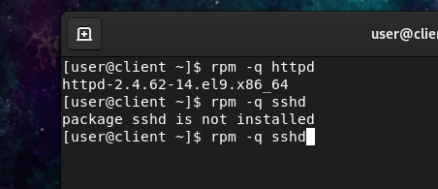

Practical 2: List All Installed Packages
rpm -qa
Example
bash
vim
httpd
openssh
firewalld

Practical 3: Get Package Information
rpm -qi bash
Output
Name : bash
Version : 5.x
Vendor : CentOS
Architecture: x86_64
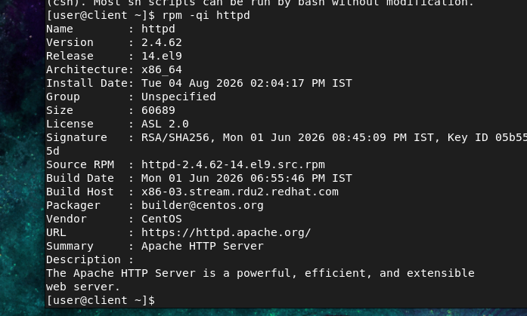

Practical 4: Show Files Installed by a Package
rpm -ql bash
Output
/bin/bash
/usr/share/doc/bash
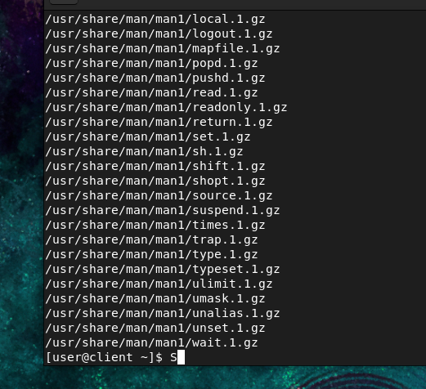

Practical 5: Install and Remove a Package
- Download the Apache RPM package (if you don't already have the .rpm file).
- Install Apache using RPM:
sudo rpm -ivh httpd-*.rpm

- -i → Install
- -v → Verbose output
- -h → Show installation progress
- Verify that Apache is installed:
rpm -q httpd

- Remove Apache using RPM:
sudo rpm -e httpd

- -e → Erase/remove the package

5.Verify that Apache has been removed:
rpm -q httpd

If removed successfully, you should see:
package httpd is not installed

2. YUM (Yellowdog Updater Modified)
What is YUM?
YUM downloads packages from online repositories.
It automatically installs required dependencies.
Advantages
- Easy to use.
- Installs dependencies automatically.

Practical 1: Install Apache
sudo yum install httpd -y
What happens?
Internet
│
▼
Downloads httpd
│
Downloads dependencies
│
Installs everything

Practical 2: Check Apache
systemctl status httpd

Practical 3: Start Apache
sudo systemctl start httpd

Practical 4: Enable Apache at Boot
sudo systemctl enable httpd

Practical 5: Remove Apache
sudo yum remove httpd -y

Practical 6: Package Information
yum info httpd
Output
Name : httpd
Version : 2.4
Repository : AppStream

3. DNF (Dandified YUM)
What is DNF?
DNF is the newer version of YUM.
It is faster and manages dependencies better.
Most newer versions of RHEL, CentOS Stream, Rocky Linux, and Fedora use DNF.

Practical 1: Install Apache
sudo dnf install httpd -y

Practical 2: List Installed Packages
dnf list installed

Practical 3: Search Package
dnf search nginx

Practical 4: Show Package Information
dnf info httpd

Practical 5: Update All Packages
sudo dnf update -y

Practical 6: Remove Package
sudo dnf remove httpd -y

